**1.Write a c program to evaluate a code for bubble sorting**

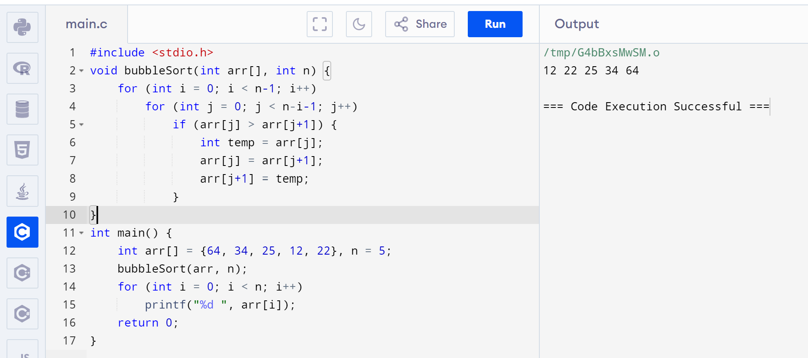

**2.Write a c program to evaluate a code for insertion sorting**

